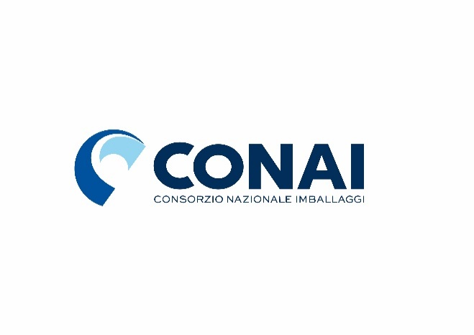

**Changes in Environmental Contributions for paper and cardboard packaging**

|  |  |  |
| --- | --- | --- |
| **CAC** | **CHANGES** | **EFFECTIVE DATE** |
| **Ordinary CAC for paper and cardboard** | FROM 25,00 TO **10,00 €/T** | As of 1 January 2022 |
| **CAC Polylaminates for liquids**  **(CPL)** | EXTRA-CAC OF 20,00 €/T UNCHANGED;  THE CONTRIBUTION WILL GO FROM 45,00 TO **30,00 €/T** | As of 1 January 2022 |
| **CAC for Type C polylaminates** | EXTRA-CAC OF **110,00 €/T**; THE CONTRIBUTION WILL GO FROM 25,00 TO **120,00 €/T** | As of 1 January 2022 |
| **CAC for Type D polylaminates and paper component not explicity** | EXTRA-CAC OF **240,00 €/**; THE CONTRIBUTION WILL GO FROM 25,00  TO **250,00 €/T** | As of 1 January 2022 |